Items measuring intentions to donate to begging EU-migrants
Donate coins to a begging EU-migrant sitting outside of your local supermarket
Donate bills to a begging EU-migrant sitting outside of your local supermarket
Donate a bag of empty cans to a begging EU-migrant sitting outside of your local supermarket
Donate food or drinks to a begging EU-migrant sitting outside of your local supermarket
Donate clothes, shoes, or blankets to a begging EU-migrant sitting outside of your local supermarket
Donate toys, kitchen utensils, or some other useful item to a begging EU-migrant sitting outside of your local supermarket
Donate money to an organization that arranges soup kitchens for begging EU-migrants in Sweden
Donate money to an organization that helps donating EU-migrants get access to medical and dental care in Sweden
Donate money to an organization that arranges shelters and provides begging EU-migrants in Sweden with opportunities to take a shower
Donate clothes, shoes, or blankets to an organization that helps EU-migrants in Sweden
Donate toys, kitchen utensils, or other useful items to an organization that helps EU-migrants in Sweden
Send sustainable foods or drinks to an organization that arranges soup kitchens for EU-migrants in Sweden
Donate money to an organization that focuses on helping poor EU-migrants in their home countries

Items measuring religiosity in Study 2b
I see myself as a religious person
I see myself as a spiritual person
I believe in a God
I am an atheist*

* Reversed
Confirmatory factor analysis of self-reported donations to charity organizations
Medical research parcels
- The Swedish cancer foundation and the Swedish childhood cancer foundation
- The Swedish heart-lung foundation and the Swedish brain foundation
International aid parcels
- Unicef Sweden and Sweden for UNHCR
- Doctors without borders and SOS children’s villages Sweden
- Red cross Sweden and Save the children Sweden
- Radio aid, Plan Sweden, and IM Swedish development partner

Estimates of fit based on the maximum likelihood method and the covariance matrix in AMOS 23.0
- Two factors: χ² (8) = 19.9, p = .011, CFI = .924, RMSEA = .033 {.015, .051}, AIC = 57.9.
- One factor: Δχ² (1) = 42.0, p < .001, χ² (9) = 61.9, p < .001, CFI = .663, RMSEA = .065 {.050, .081}, AIC = 97.9.
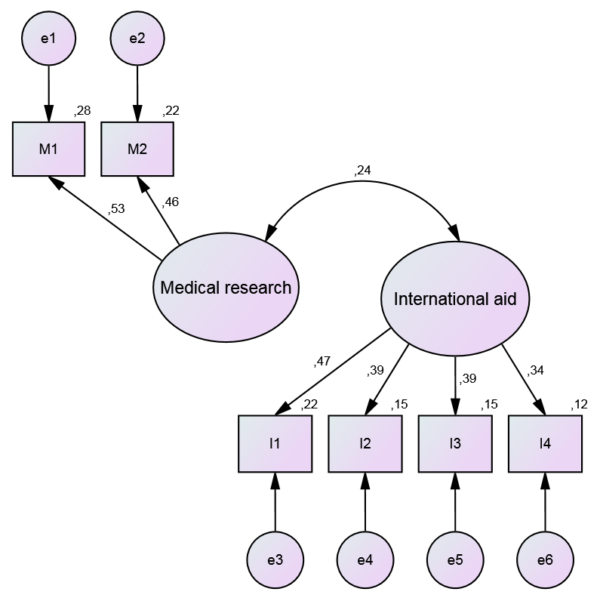
Study 2a: Charity ads
The ads were inspired by “Face of the fame”, Minhaj, before and after, http://www.rescue.org/blog/face-famine-baby-minhaj-before-after
The Swedish original ads are followed by translations into English. The negative appeal is presented first, followed by the positive appeal.
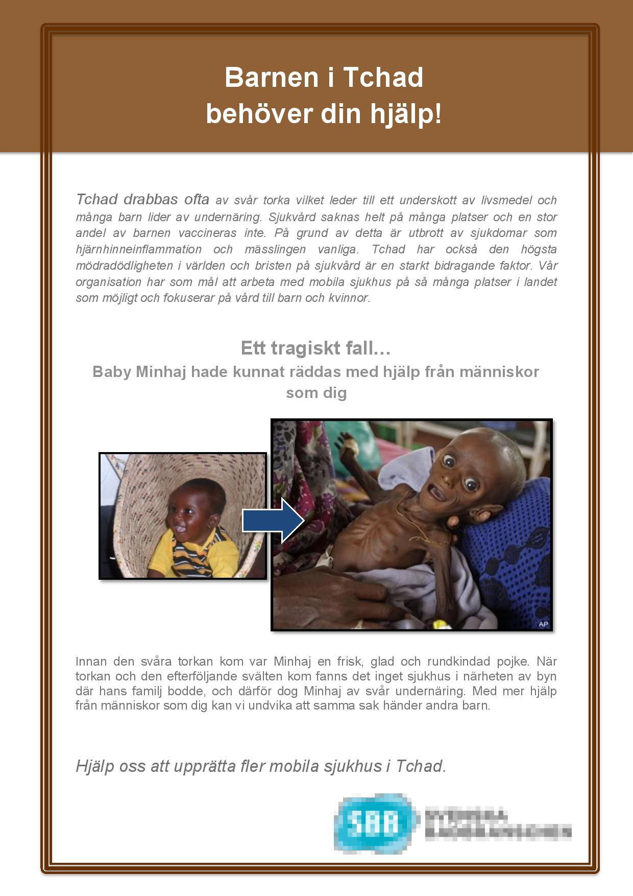
The children of Tchad need your help!
Tchad is often struck by difficult drought, which leads to a lack of food, and many children suffer from malnourishment. Healthcare is completely absent in many locations and a lot of children are not vaccinated. Because of this, outbreaks of diseases such as meningitis and measles are common. Tchad also has the highest maternal mortality in the world and the lack of healthcare greatly contributes to this situation. Our organization seeks to promote mobile hospitals in as many different locations in Tchad as possible and focuses on providing healthcare to children and women.

A tragic story…
Baby Minhaj could have been saved by help from people like you!
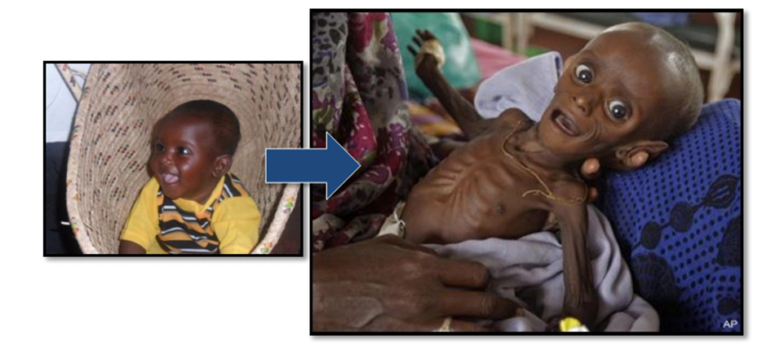
Baby Minhaj used to be a healthy, happy, round-cheeked boy but when the severe drought and the subsequent famine struck, there was unfortunately no clinic close to the village where his family lived so Baby Minhaj died from acute malnourishment. With more help from people like you, we can avoid the same terrible thing happening to other children

Help us to establish more mobile hospitals in Tchad!

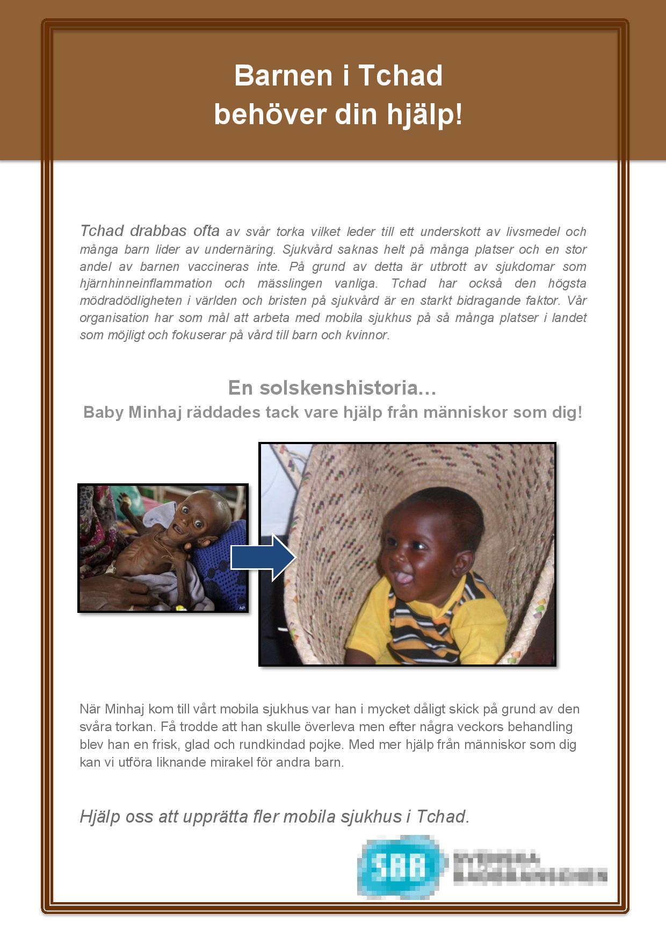

The children of Tchad need your help!
Tchad is often struck by difficult drought, which leads to a lack of food, and many children suffer from malnourishment. Healthcare is completely absent in many locations and a lot of children are not vaccinated. Because of this, outbreaks of diseases such as meningitis and measles are common. Tchad also has the highest maternal mortality in the world and the lack of healthcare greatly contributes to this situation. Our organization seeks to promote mobile hospitals in as many different locations in Tchad as possible and focuses on providing healthcare to children and women.

A sunshine story…
Baby Minhaj was saved because of help from people like you!
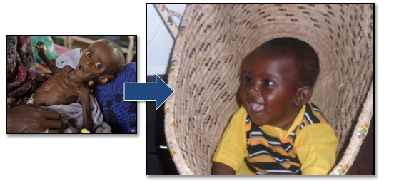
When Baby Minhaj came to our mobile clinic, he was in a very bad state due to the severe drought and subsequent famine. Few expected him to survive, but after a couple of week’s treatment he was back to being a healthy, happy and round-cheeked boy. With more help from people like you, we can make the same miracle happen for other children.

Help us to establish more mobile hospitals in Tchad!

Study 2b: Charity ads
Negative appeal

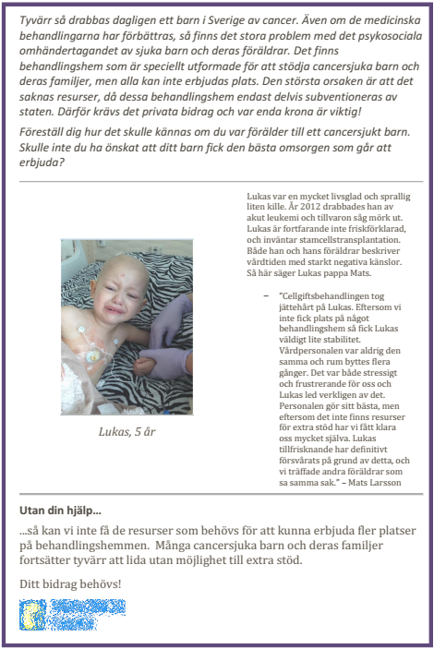

Each day, one child in Sweden gets a cancer diagnosis. Although medical treatments have improved, there are still problems with psychosocial care given to sick children and their families. There are care centers specifically designed to provide support for children with cancer and their families, but there is not room for everyone. The main reason for this is lack of resources, because only a part of the expenses are covered by the government. Private donations are necessary and every penny is valuable!
Imagine how it would feel if you were parent of a child who is afflicted with cancer. Would you not wish that your child got the best care possible?

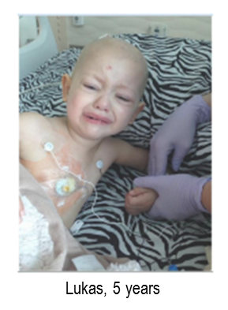
Lukas was a very happy and playful boy. In 2012 he was diagnosed with acute Leukemia and his future looked bleak. Lukas is still not cured and is waiting for a bone marrow transplant. Both Lukas and his parents look back at the time in care with very negative emotions. This is what Lukas’ father Mats has to say about it.
The chemotherapy was difficult for Lukas. Because there was not enough room at any care center, Lukas did not get the stability that he needed. The personnel were never the same and Lukas had to change room many times. It was stressful and frustrating for us and Lukas really suffered. The personnel do the best they can, but because there are not enough resources for support, we had to manage a lot of our own. Lukas’ medical situation has surely been hampered because of this, and we met other parents who said the same thing. (Mats Larsson)

Without your help…
…we cannot acquire the resources needed to be able to provide more children room in a care center. Many children and their families continue to suffer without the opportunity to receive sufficient support.

Your contribution is needed!

Positive appeal

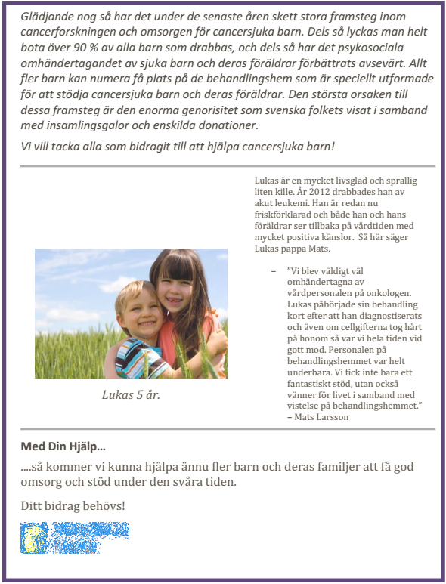

Fortunately, there have been great advances in cancer research and health care for children who have cancer over the past years. 90% of all diagnosed children are cured and the psychosocial care of the afflicted children and their families has also been considerably improved. More children are now able to stay at the care centers specifically designed to provide support for children with cancer and their families. The main reason for this is the enormous generosity shown by the Swedish people at fund raising events and through private donations.
We want to thank everyone who has contributed to helping children who have cancer!

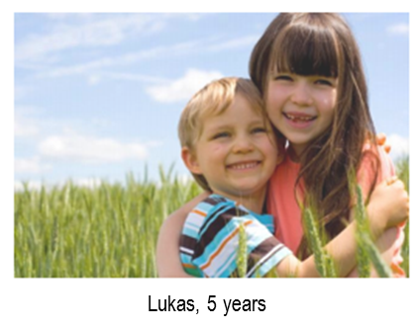
Lukas is a very happy and playful boy. In 2012 he was diagnosed with acute Leukemia. Lukas is already cured and both Lukas and his parents look back at the time in care with very positive emotions. This is what Lukas’ father Mats has to say about it.
We were all very well taken care of by the personnel at the oncological clinic as well as the care center. Lukas began his medical treatment shortly after being diagnosed and although the chemotherapy was tough, we always stayed positive. The people at the care center were terrific. We not only received the best care and support possible, we also made wonderful new friends during the time at the care center (Mats Larsson)

With your help…
…will be able to give even more children and their families the care and support they need during their difficult times.

Your contribution is needed!

